CISC 352: Artificial Intelligence
Project Check-In
Vedansh Bhatt
20416335
March 8, 2026

CISC 352 – Progress Report
Introduction
The game of chess has long piqued the interest of humans and robots alike. With tremendous growth in computing power in recent decades, alongside specialized supercomputer developments, the game has become a platform in which intelligence decision-making can be studied and evaluated. While chess engines calculate deep tactical variations, human enthusiasts reason about the state of the board at a higher strategic level, thinking about plans that may improve piece coordination, control key squares, or prepare an attack on the opponent. This project aims to study how artificial intelligence techniques can be used to evaluate these ideas.
The principal challenge arises from the sheer complexity of chess and the unpredictability of an opponent’s response. Hence, rather than evaluating isolated moves, our approach will focus on reasoning about multi-move ideas, estimating their likelihood of success. To address this problem, we will integrate three foundational AI techniques discussed in this course. Namely, automated planning is used to generate and analyze candidate move sequences, probabilistic inference models uncertainty in opponent responses, and deep learning offers a learned evaluation bar for assessing resulting positions.
In summary, the following project, entitled Before You Move, provides an experimental framework for comparing how the different AI techniques studied in this course evaluate candidate plans and predict their strategic effectiveness.
Problem Formulation
To tackle this problem, we model strategic decision-making in chess as a planning problem defined over board states and legal actions. Consider the following:
- A state corresponds to a chess position represented by its board configuration (FEN string)
- An action corresponds to legal moves available to the side whose turn it is to play
- A plan is a sequence of moves representing a specific idea or continuation
Since opponent responses are unknown, each plan branches out to a set of possible future states, and the objective of the system is to estimate the likelihood that executing a given plan will lead to a favourable position, as defined by the learned evaluation bar.
AI Techniques
Automated Planning
To generate and evaluate candidate ideas, we implement a bounded lookahead planner, exploring short sequences of moves from a given position. For a given position, the planner enumerates all legal moves and constructs potential plans by simulating short continuations. Each plan is then evaluated using a depth-limited search. In the current implementation, the planner evaluates up to N legal moves and finds continuations to a depth of D plies, ranking them on the average evaluation of the resulting positions. Consider for example, the following position, depicting the classic setup for the Fried Liver Attack:
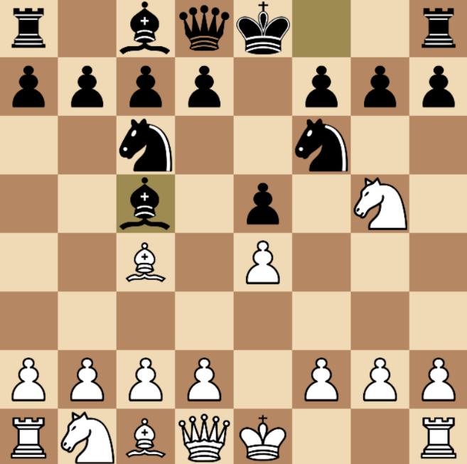
Figure 1: Fried Liver Attack – Nxf7 forks the Queen and Rook
In this position, all generated plans encourage white to capture on f7, as seen below:
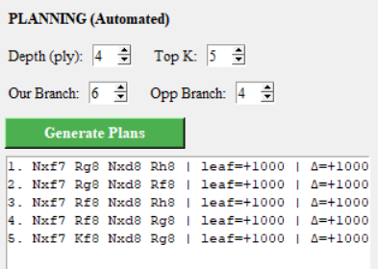
Figure 2: Top five plans generated for White
Probabilistic Inference
Although automated planning generates move sequences, the outcome of a plan hinges on the opponent’s response. We model this uncertainty by incorporating probabilistic inference to estimate the likelihood that a given move will lead to a winning position. As such, for each legal move, the system simulates multiple continuations in which the opponent is assumed to choose among strong responses (this is still a work in progress). These simulations allow the system to compute P(success | move), the probability of success given that a certain move is played. Preliminary experiments show that moves with strong positional foundations achieve higher success probabilities, while speculative moves (Fool’s Mate, Scholar’s Mate, etc.) exhibit greater variance.
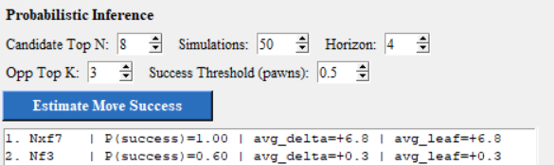
Figure 3: Estimated chances of success for the top two moves in the position shown in Figure 1
Deep Learning
To complement the planning and probabilistic components of the system, we incorporate a lightweight neural network to learn and evaluation function for chess positions. The training data is generated automatically through the Stockfish chess engine, which evaluates a large number of positions and provides numerical scores representing the expected advantage. Positions are represented through FEN strings, and the neural network is trained to approximate the evaluation produced by Stockfish, learning to predict the value of a position directly from the board state. Once trained, the network can reasonably estimate the value of positions encountered throughout the entire game, offering a complementary signal to the much simpler material-based evaluation used earlier on.
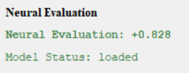
Figure 4: Neural Evaluation for the position shown in Figure 1

